NOMBRE DE LA MATERIA

Fundamento de Redes

NOMBRE DEL DOCENTE

Rafael Preciado Gutiérrez

NOMBRE DEL TRABAJO

Actividad 6

NOMBRE DEL ALUMNO

Alejandro Guevara de Luna

UNIDAD

2

FECHA Y LUGAR

27 de octubre del 2022

Dispositivos:

CDMX:

|  |  |
| --- | --- |
| 2 Routers |  |
| 3 Switch |  |
| 1 Server |  |
| 45 PC’s |  |

MTY:

|  |  |
| --- | --- |
| 2 Routers |  |
| 4 Switch |  |
| 20 PC’s |  |

GLD:

|  |  |
| --- | --- |
| 1 Router |  |
| 2 Switch |  |
| 30 PC’s |  |

IP’s de los dispositivos:

Global:

|  |  |  |  |  |
| --- | --- | --- | --- | --- |
| Dispositivo | Puerto | IPv4 | Mascara | Gateway |
| Router G | S 0/0 | 192.168.11.1 | 255.255.255.0 | NA |
| S 0/1 | 192.168.12.1 | 255.255.255.0 | NA |
| S 1/0 | 192.168.13.1 | 255.255.255.0 | NA |

CDMX:

|  |  |  |  |  |
| --- | --- | --- | --- | --- |
| Dispositivo | Puerto | IPv4 | Mascara | Gateway |
| Router 1 | S 0/0 | 192.168.0.1 | 255.255.255.0 | NA |
| S 0/1 | 192.168.11.2 | 255.255.255.0 | NA |
| Fa 0/0 | 192.167.0.1 | 255.255.255.0 | NA |
| Fa 0/1 | 192.168.4.1 | 255.255.255.0 | NA |
| Router 2 | S 0/0 | 192.168.0.2 | 255.255.255.0 | NA |
| Fa 0/0 | 192.168.2.1 | 255.255.255.0 | NA |
| Fa 0/1 | 192.168.3.1 | 255.255.255.0 | NA |
| Server 1 | Fa 0/0 | 192.167.0.2 | 255.255.255.0 | 192.167.0.1 |
| PC1 | Fa 0/0 | 192.168.2.2 | 255.255.255.0 | 192.168.2.1 |
| PC2 | Fa 0/0 | 192.168.2.3 | 255.255.255.0 | 192.168.2.1 |
| PC3 | Fa 0/0 | 192.168.2.4 | 255.255.255.0 | 192.168.2.1 |
| PC4 | Fa 0/0 | 192.168.2.5 | 255.255.255.0 | 192.168.2.1 |
| PC5 | Fa 0/0 | 192.168.2.6 | 255.255.255.0 | 192.168.2.1 |
| PC6 | Fa 0/0 | 192.168.2.7 | 255.255.255.0 | 192.168.2.1 |
| PC7 | Fa 0/0 | 192.168.2.8 | 255.255.255.0 | 192.168.2.1 |
| PC8 | Fa 0/0 | 192.168.2.9 | 255.255.255.0 | 192.168.2.1 |
| PC9 | Fa 0/0 | 192.168.2.10 | 255.255.255.0 | 192.168.2.1 |
| PC10 | Fa 0/0 | 192.168.2.11 | 255.255.255.0 | 192.168.2.1 |
| PC11 | Fa 0/0 | 192.168.2.12 | 255.255.255.0 | 192.168.2.1 |
| PC12 | Fa 0/0 | 192.168.2.13 | 255.255.255.0 | 192.168.2.1 |
| PC13 | Fa 0/0 | 192.168.2.14 | 255.255.255.0 | 192.168.2.1 |
| PC14 | Fa 0/0 | 192.168.2.15 | 255.255.255.0 | 192.168.2.1 |
| PC15 | Fa 0/0 | 192.168.2.16 | 255.255.255.0 | 192.168.2.1 |
| PC16 | Fa 0/0 | 192.168.2.17 | 255.255.255.0 | 192.168.2.1 |
| PC17 | Fa 0/0 | 192.168.2.18 | 255.255.255.0 | 192.168.2.1 |
| PC18 | Fa 0/0 | 192.168.2.19 | 255.255.255.0 | 192.168.2.1 |
| PC19 | Fa 0/0 | 192.168.2.20 | 255.255.255.0 | 192.168.2.1 |
| PC20 | Fa 0/0 | 192.168.2.21 | 255.255.255.0 | 192.168.2.1 |
| PC21 | Fa 0/0 | 192.168.3.2 | 255.255.255.0 | 192.168.3.1 |
| PC22 | Fa 0/0 | 192.168.3.3 | 255.255.255.0 | 192.168.3.1 |
| PC23 | Fa 0/0 | 192.168.3.4 | 255.255.255.0 | 192.168.3.1 |
| PC24 | Fa 0/0 | 192.168.3.5 | 255.255.255.0 | 192.168.3.1 |
| PC25 | Fa 0/0 | 192.168.3.6 | 255.255.255.0 | 192.168.3.1 |
| PC26 | Fa 0/0 | 192.168.3.7 | 255.255.255.0 | 192.168.3.1 |
| PC27 | Fa 0/0 | 192.168.3.8 | 255.255.255.0 | 192.168.3.1 |
| PC28 | Fa 0/0 | 192.168.3.9 | 255.255.255.0 | 192.168.3.1 |
| PC29 | Fa 0/0 | 192.168.3.10 | 255.255.255.0 | 192.168.3.1 |
| PC30 | Fa 0/0 | 192.168.3.11 | 255.255.255.0 | 192.168.3.1 |
| PC31 | Fa 0/0 | 192.168.4.2 | 255.255.255.0 | 192.168.4.1 |
| PC32 | Fa 0/0 | 192.168.4.3 | 255.255.255.0 | 192.168.4.1 |
| PC33 | Fa 0/0 | 192.168.4.4 | 255.255.255.0 | 192.168.4.1 |
| PC34 | Fa 0/0 | 192.168.4.5 | 255.255.255.0 | 192.168.4.1 |
| PC35 | Fa 0/0 | 192.168.4.6 | 255.255.255.0 | 192.168.4.1 |
| PC36 | Fa 0/0 | 192.168.4.7 | 255.255.255.0 | 192.168.4.1 |
| PC37 | Fa 0/0 | 192.168.4.8 | 255.255.255.0 | 192.168.4.1 |
| PC38 | Fa 0/0 | 192.168.4.9 | 255.255.255.0 | 192.168.4.1 |
| PC39 | Fa 0/0 | 192.168.4.10 | 255.255.255.0 | 192.168.4.1 |
| PC40 | Fa 0/0 | 192.168.4.11 | 255.255.255.0 | 192.168.4.1 |
| PC41 | Fa 0/0 | 192.168.4.12 | 255.255.255.0 | 192.168.4.1 |
| PC42 | Fa 0/0 | 192.168.4.13 | 255.255.255.0 | 192.168.4.1 |
| PC43 | Fa 0/0 | 192.168.4.14 | 255.255.255.0 | 192.168.4.1 |
| PC44 | Fa 0/0 | 192.168.4.15 | 255.255.255.0 | 192.168.4.1 |
| PC45 | Fa 0/0 | 192.168.4.16 | 255.255.255.0 | 192.168.4.1 |

MTY:

|  |  |  |  |  |
| --- | --- | --- | --- | --- |
| Dispositivo | Puerto | IPv4 | Mascara | Gateway |
| Router 1 | S 0/0 | 192.168.1.1 | 255.255.255.0 | NA |
| S 0/1 | 192.168.12.2 | 255.255.255.0 | NA |
| Fa 0/0 | 192.168.5.1 | 255.255.255.0 | NA |
| Fa 0/1 | 192.168.6.1 | 255.255.255.0 | NA |
| Router 2 | S 0/0 | 192.168.1.2 | 255.255.255.0 | NA |
| Fa 0/0 | 192.168.7.1 | 255.255.255.0 | NA |
| Fa 0/1 | 192.168.8.1 | 255.255.255.0 | NA |
| PC1 | Fa 0/0 | 192.168.5.2 | 255.255.255.0 | 192.168.5.1 |
| PC2 | Fa 0/0 | 192.168.5.3 | 255.255.255.0 | 192.168.5.1 |
| PC3 | Fa 0/0 | 192.168.5.4 | 255.255.255.0 | 192.168.5.1 |
| PC4 | Fa 0/0 | 192.168.5.5 | 255.255.255.0 | 192.168.5.1 |
| PC5 | Fa 0/0 | 192.168.5.6 | 255.255.255.0 | 192.168.5.1 |
| PC6 | Fa 0/0 | 192.168.5.7 | 255.255.255.0 | 192.168.5.1 |
| PC7 | Fa 0/0 | 192.168.5.8 | 255.255.255.0 | 192.168.5.1 |
| PC8 | Fa 0/0 | 192.168.5.9 | 255.255.255.0 | 192.168.5.1 |
| PC9 | Fa 0/0 | 192.168.5.10 | 255.255.255.0 | 192.168.5.1 |
| PC10 | Fa 0/0 | 192.168.5.11 | 255.255.255.0 | 192.168.5.1 |
| PC11 | Fa 0/0 | 192.168.6.2 | 255.255.255.0 | 192.168.6.1 |
| PC12 | Fa 0/0 | 192.168.6.3 | 255.255.255.0 | 192.168.6.1 |
| PC13 | Fa 0/0 | 192.168.6.4 | 255.255.255.0 | 192.168.6.1 |
| PC14 | Fa 0/0 | 192.168.6.5 | 255.255.255.0 | 192.168.6.1 |
| PC15 | Fa 0/0 | 192.168.6.6 | 255.255.255.0 | 192.168.6.1 |
| PC16 | Fa 0/0 | 192.168.6.7 | 255.255.255.0 | 192.168.6.1 |
| PC17 | Fa 0/0 | 192.168.6.8 | 255.255.255.0 | 192.168.6.1 |
| PC18 | Fa 0/0 | 192.168.6.9 | 255.255.255.0 | 192.168.6.1 |
| PC19 | Fa 0/0 | 192.168.6.10 | 255.255.255.0 | 192.168.6.1 |
| PC20 | Fa 0/0 | 192.168.6.11 | 255.255.255.0 | 192.168.6.1 |
| PC21 | Fa 0/0 | 192.168.7.2 | 255.255.255.0 | 192.168.7.1 |
| PC22 | Fa 0/0 | 192.168.7.3 | 255.255.255.0 | 192.168.7.1 |
| PC23 | Fa 0/0 | 192.168.7.4 | 255.255.255.0 | 192.168.7.1 |
| PC24 | Fa 0/0 | 192.168.7.5 | 255.255.255.0 | 192.168.7.1 |
| PC25 | Fa 0/0 | 192.168.7.6 | 255.255.255.0 | 192.168.7.1 |
| PC26 | Fa 0/0 | 192.168.7.7 | 255.255.255.0 | 192.168.7.1 |
| PC27 | Fa 0/0 | 192.168.7.8 | 255.255.255.0 | 192.168.7.1 |
| PC28 | Fa 0/0 | 192.168.7.9 | 255.255.255.0 | 192.168.7.1 |
| PC29 | Fa 0/0 | 192.168.7.10 | 255.255.255.0 | 192.168.7.1 |
| PC30 | Fa 0/0 | 192.168.7.11 | 255.255.255.0 | 192.168.7.1 |
| PC31 | Fa 0/0 | 192.168.8.2 | 255.255.255.0 | 192.168.8.1 |
| PC32 | Fa 0/0 | 192.168.8.3 | 255.255.255.0 | 192.168.8.1 |
| PC33 | Fa 0/0 | 192.168.8.4 | 255.255.255.0 | 192.168.8.1 |
| PC34 | Fa 0/0 | 192.168.8.5 | 255.255.255.0 | 192.168.8.1 |
| PC35 | Fa 0/0 | 192.168.8.6 | 255.255.255.0 | 192.168.8.1 |
| PC36 | Fa 0/0 | 192.168.8.7 | 255.255.255.0 | 192.168.8.1 |
| PC37 | Fa 0/0 | 192.168.8.8 | 255.255.255.0 | 192.168.8.1 |
| PC38 | Fa 0/0 | 192.168.8.9 | 255.255.255.0 | 192.168.8.1 |
| PC39 | Fa 0/0 | 192.168.8.10 | 255.255.255.0 | 192.168.8.1 |
| PC40 | Fa 0/0 | 192.168.8.11 | 255.255.255.0 | 192.168.8.1 |

GDL:

|  |  |  |  |  |
| --- | --- | --- | --- | --- |
| Dispositivo | Puerto | IPv4 | Mascara | Gateway |
| Router 1 | S 0/0 | 192.168.13.1 | 255.255.255.0 | NA |
| Fa 0/0 | 192.168.9.1 | 255.255.255.0 | NA |
| Fa 0/1 | 192.168.10.1 | 255.255.255.0 | NA |
| PC1 | Fa 0/0 | 192.168.9.2 | 255.255.255.0 | 192.168.9.1 |
| PC2 | Fa 0/0 | 192.168.9.3 | 255.255.255.0 | 192.168.9.1 |
| PC3 | Fa 0/0 | 192.168.9.4 | 255.255.255.0 | 192.168.9.1 |
| PC4 | Fa 0/0 | 192.168.9.5 | 255.255.255.0 | 192.168.9.1 |
| PC5 | Fa 0/0 | 192.168.9.6 | 255.255.255.0 | 192.168.9.1 |
| PC6 | Fa 0/0 | 192.168.9.7 | 255.255.255.0 | 192.168.9.1 |
| PC7 | Fa 0/0 | 192.168.9.8 | 255.255.255.0 | 192.168.9.1 |
| PC8 | Fa 0/0 | 192.168.9.9 | 255.255.255.0 | 192.168.9.1 |
| PC9 | Fa 0/0 | 192.168.9.10 | 255.255.255.0 | 192.168.9.1 |
| PC10 | Fa 0/0 | 192.168.9.11 | 255.255.255.0 | 192.168.9.1 |
| PC11 | Fa 0/0 | 192.168.9.12 | 255.255.255.0 | 192.168.9.1 |
| PC12 | Fa 0/0 | 192.168.9.13 | 255.255.255.0 | 192.168.9.1 |
| PC13 | Fa 0/0 | 192.168.9.14 | 255.255.255.0 | 192.168.9.1 |
| PC14 | Fa 0/0 | 192.168.9.15 | 255.255.255.0 | 192.168.9.1 |
| PC15 | Fa 0/0 | 192.168.9.16 | 255.255.255.0 | 192.168.9.1 |
| PC16 | Fa 0/0 | 192.168.10.2 | 255.255.255.0 | 192.168.10.1 |
| PC17 | Fa 0/0 | 192.168.10.3 | 255.255.255.0 | 192.168.10.1 |
| PC18 | Fa 0/0 | 192.168.10.4 | 255.255.255.0 | 192.168.10.1 |
| PC19 | Fa 0/0 | 192.168.10.5 | 255.255.255.0 | 192.168.10.1 |
| PC20 | Fa 0/0 | 192.168.10.6 | 255.255.255.0 | 192.168.10.1 |
| PC21 | Fa 0/0 | 192.168.10.7 | 255.255.255.0 | 192.168.10.1 |
| PC22 | Fa 0/0 | 192.168.10.8 | 255.255.255.0 | 192.168.10.1 |
| PC23 | Fa 0/0 | 192.168.10.9 | 255.255.255.0 | 192.168.10.1 |
| PC24 | Fa 0/0 | 192.168.10.10 | 255.255.255.0 | 192.168.10.1 |
| PC25 | Fa 0/0 | 192.168.10.11 | 255.255.255.0 | 192.168.10.1 |
| PC26 | Fa 0/0 | 192.168.10.12 | 255.255.255.0 | 192.168.10.1 |
| PC27 | Fa 0/0 | 192.168.10.13 | 255.255.255.0 | 192.168.10.1 |
| PC28 | Fa 0/0 | 192.168.10.14 | 255.255.255.0 | 192.168.10.1 |
| PC29 | Fa 0/0 | 192.168.10.15 | 255.255.255.0 | 192.168.10.1 |
| PC30 | Fa 0/0 | 192.168.10.16 | 255.255.255.0 | 192.168.10.1 |

Precios:

Router: $372,639.00

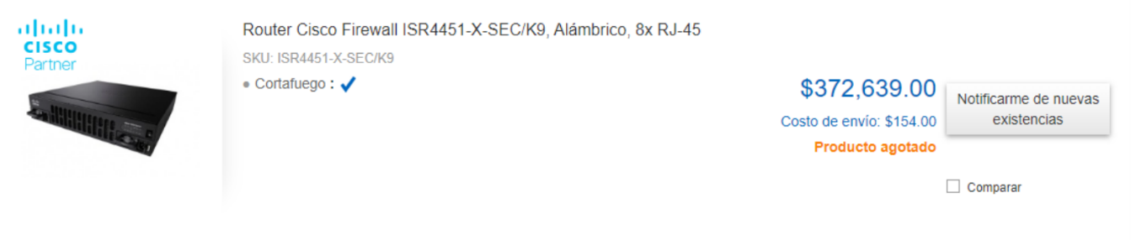

Switch: $19,529.00

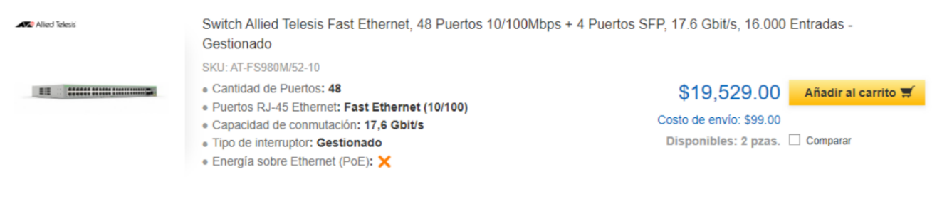

PC: $10,000.00

Server: $384,829.00

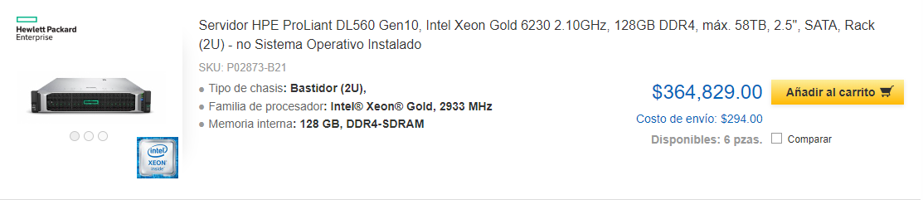

Costo de la red:

|  |  |
| --- | --- |
| Estado | Precio |
| CDMX   * 2 Routers * 3 Switch * 1 Servidor * 45 PC | $1,638,694.00 |
| MTY   * 2 Routers * 4 Switch * 20 PC’s | $1,023,394.00 |
| GDL   * 1 Router * 2 Switch * 30 PC’s | $711,697.00 |
| Total | **$3,373,785.00** |

Conexión de los dispositivos:

CDMX:

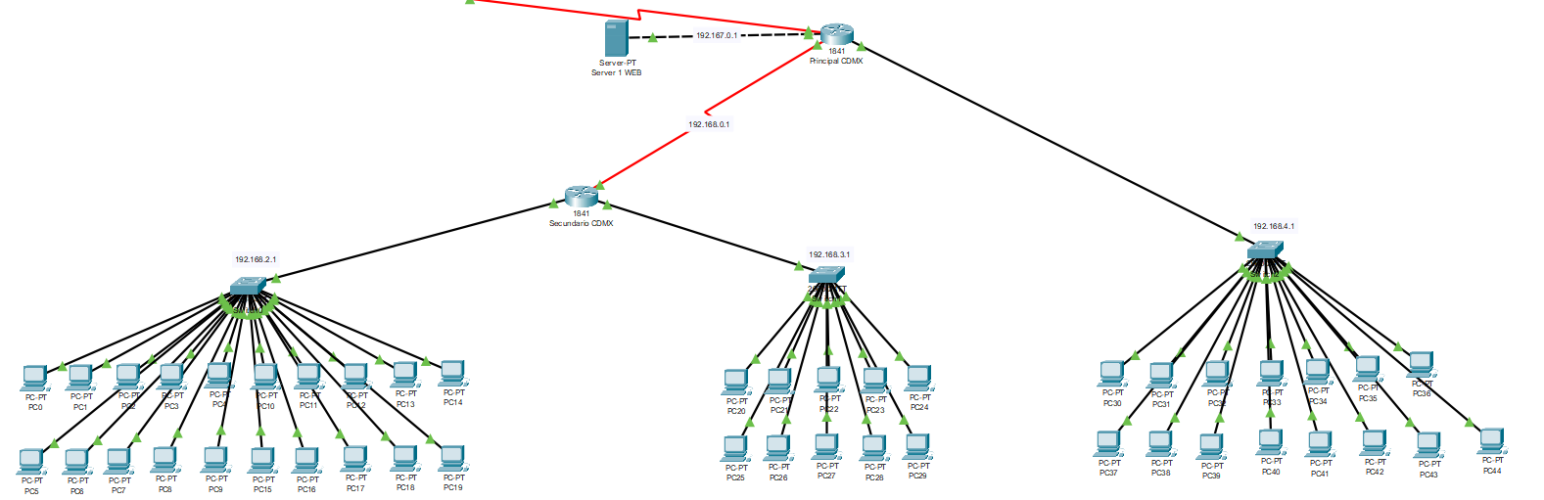

MTY:

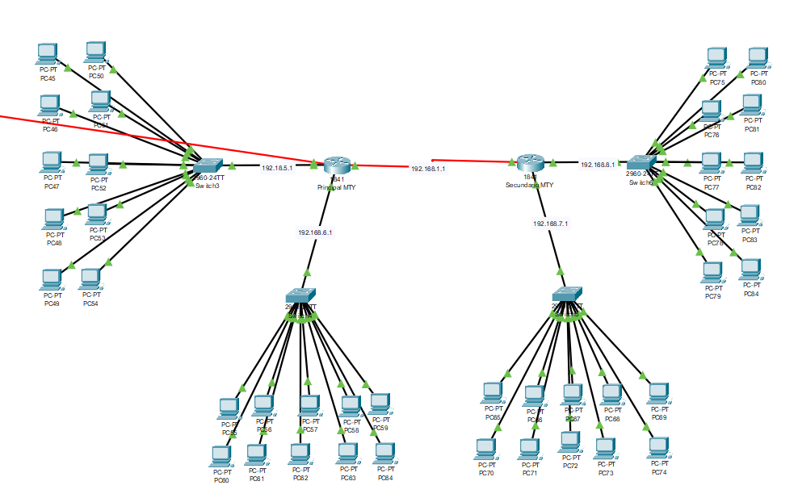

GDL:

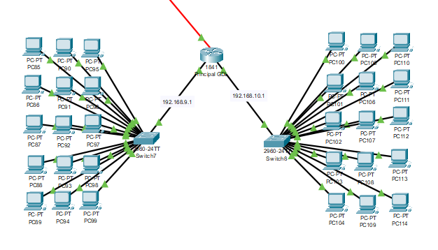

Global:

